Nama : Astiany Dwi Prasinta

NIM : 18090059

**PRAKTIKUM 4**

1. Source Code

Web -> Application/Controller/web.php

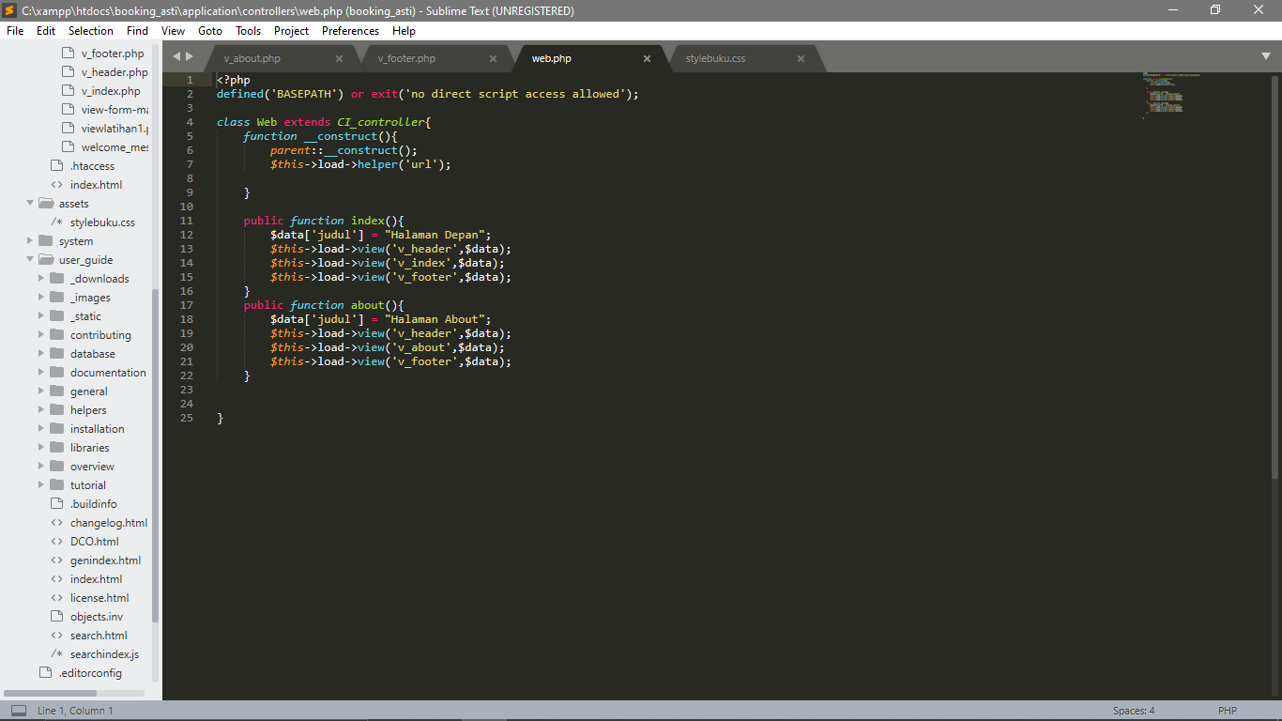

View header -> Application/view/v_header.php

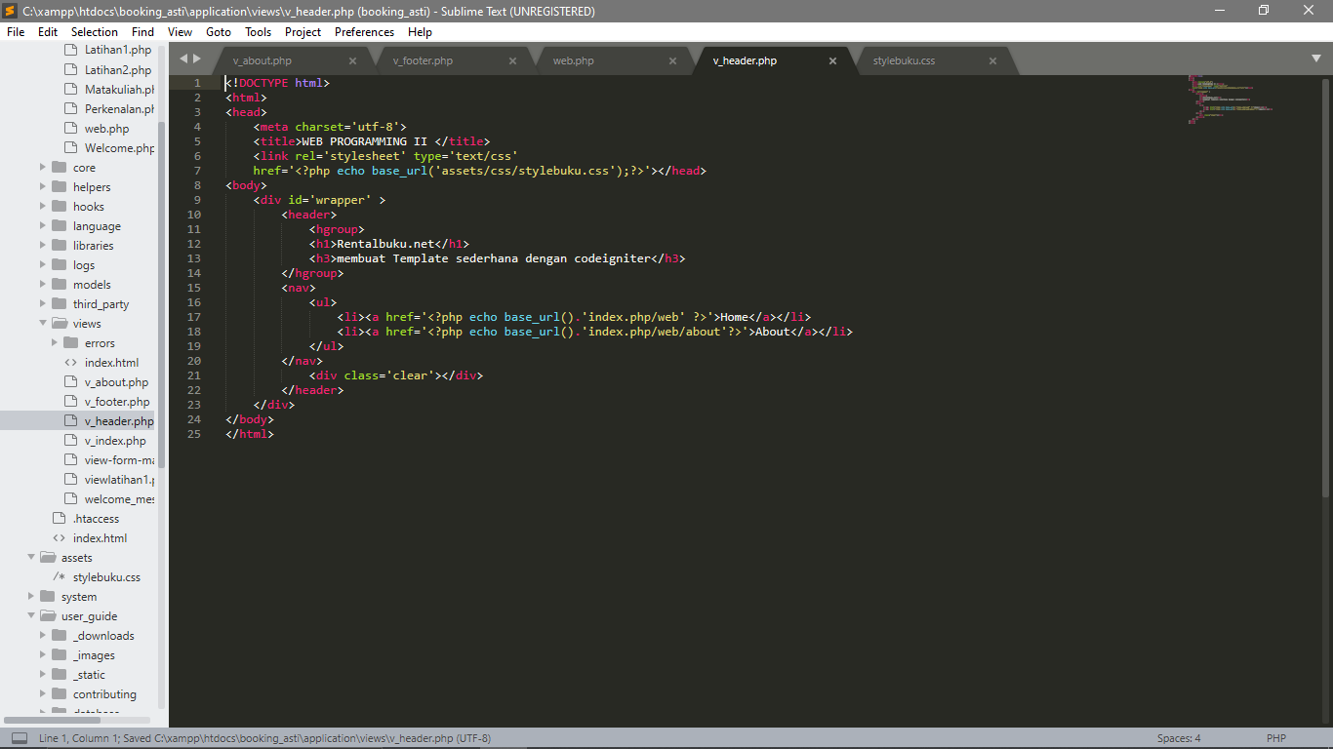

View index ->Application/view/v_index.php

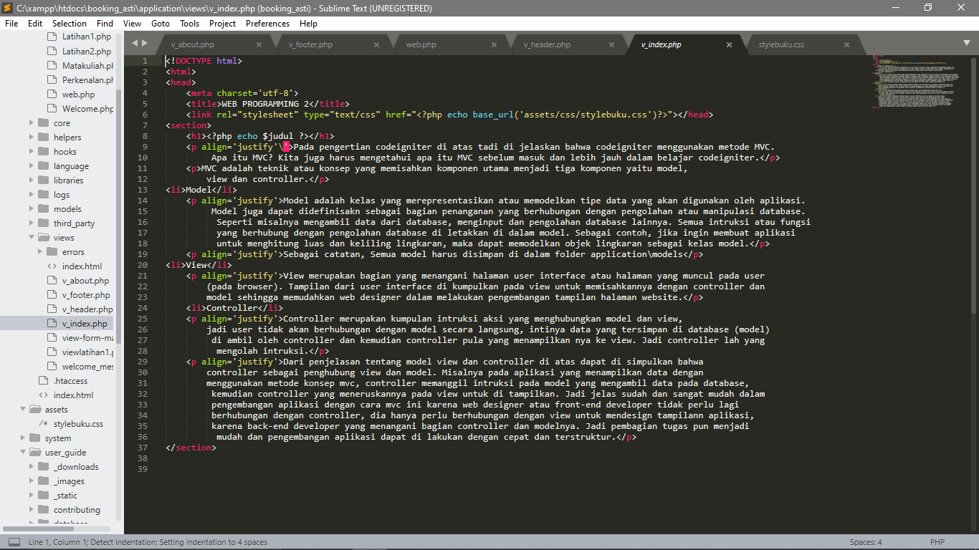

View footer -> Application/view/v_footer.php

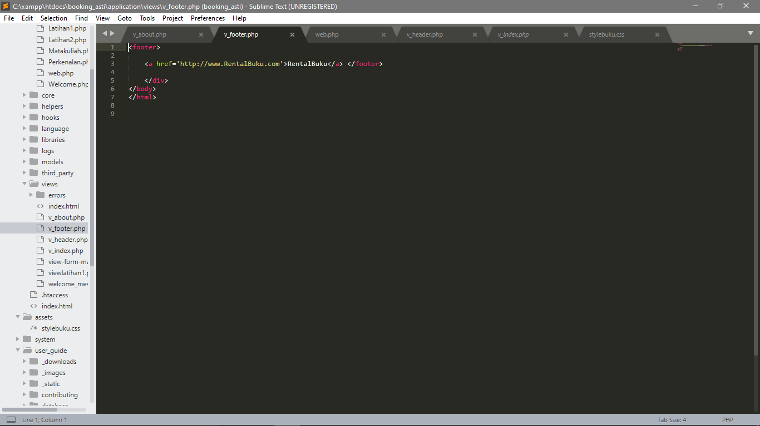

View about -> Application/view/v_about.php

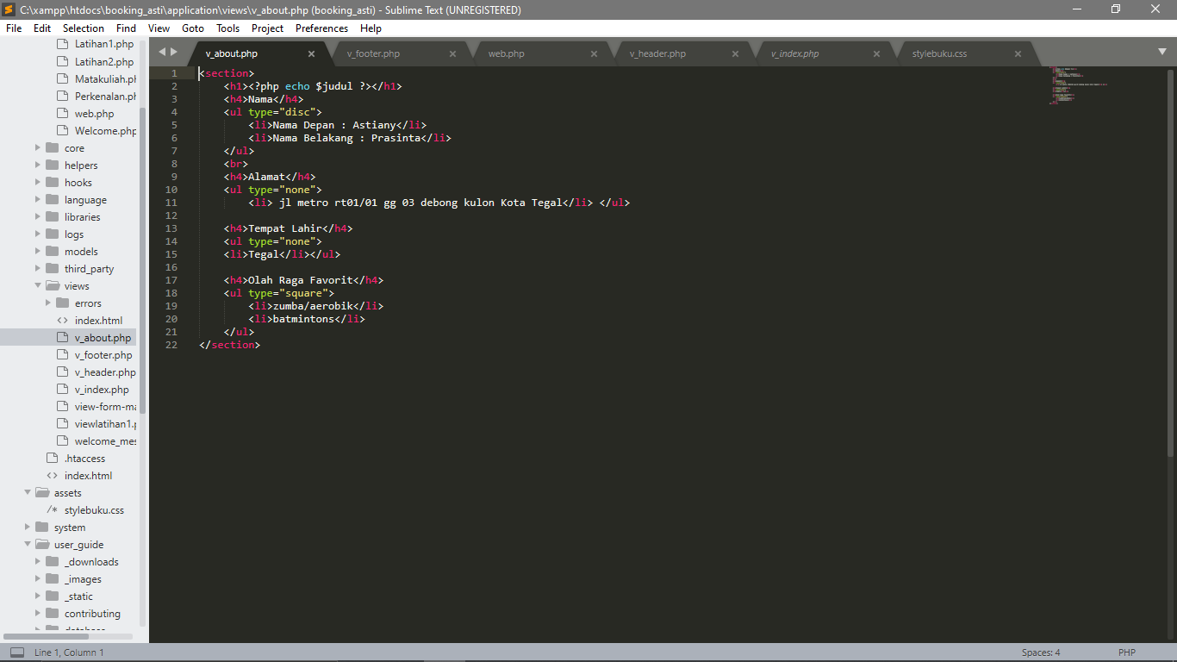

Stylebuku.css -> assets/css

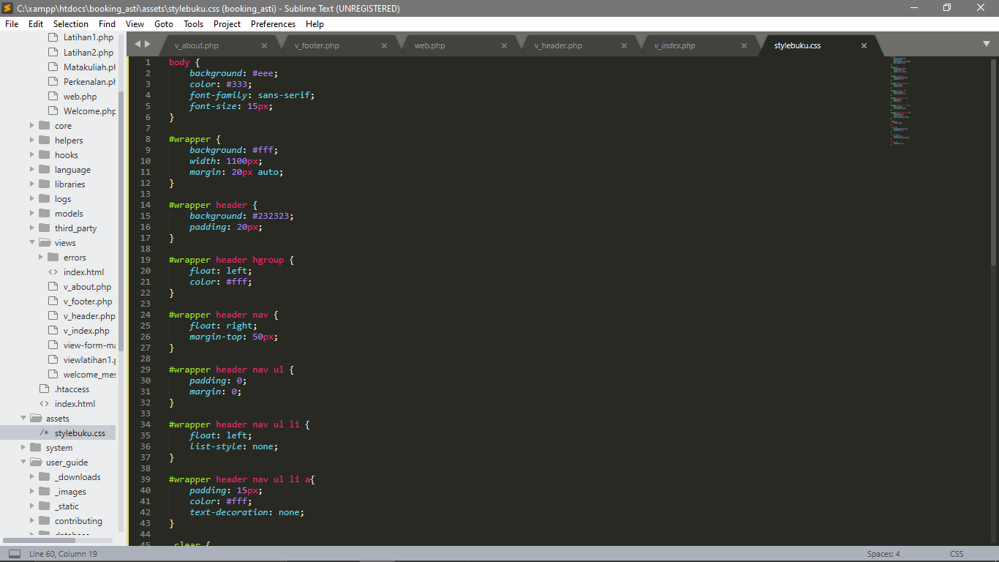

Config -> Application/config.php

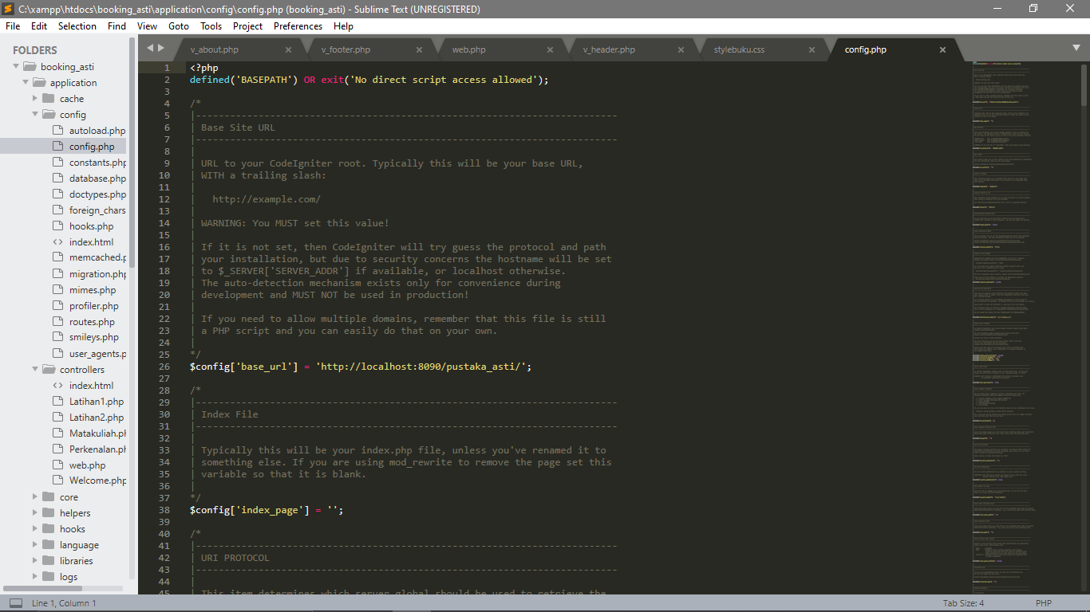

Autoload.php -> Application/config

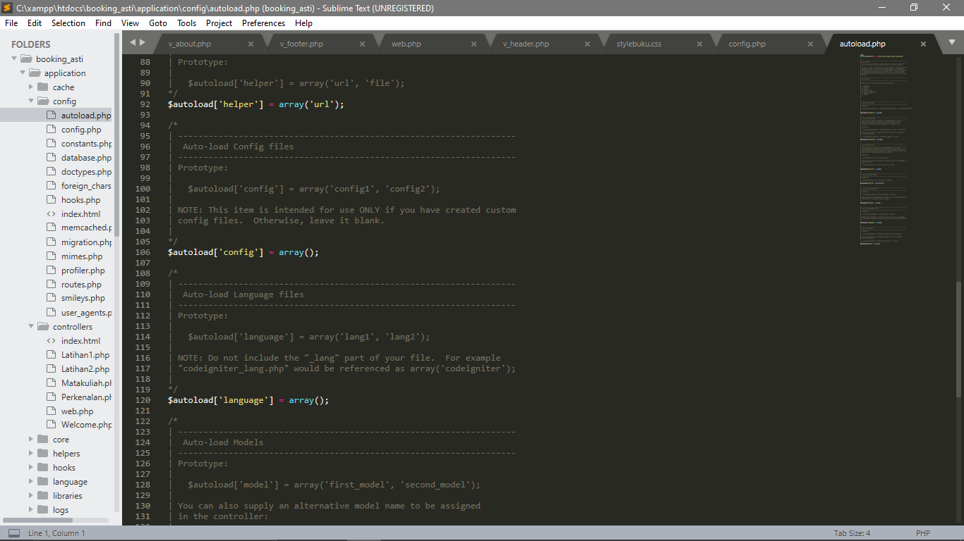

1. URL

<http://localhost/booking_asti/index.php/web/about>

<http://localhost/booking_asti/index.php/web>

1. Output

